Environmental Science
2020-2021 Syllabus
Ms. DeLeon email: christina.deleon@cobbk12.org Room 1207
General Office hours: 11:30 – 3:30 Wednesday or appointment by request
Parent Conferences: Monday-Thursday 3:30 -4:30
Overview of environmental science class

In this class, you will:
- Look at the world around you with curiosity and questions
- Discuss multiple perspectives to arrive at a deep understanding of questions and problems
- Investigate and research possible solutions
- Analyze data and observations
- Collaborate to analyze the strengths and weaknesses of various solutions
- Support your arguments with evidence and discussion of counterpoints
- Report your results using appropriate scientific charts, graphs, and writing

Daily materials
- Pencil/Pen
- Notebook Paper
- Folder or Binder
- Basic Calculator

Other helpful items:
- Colored pencils or markers
- Ruler

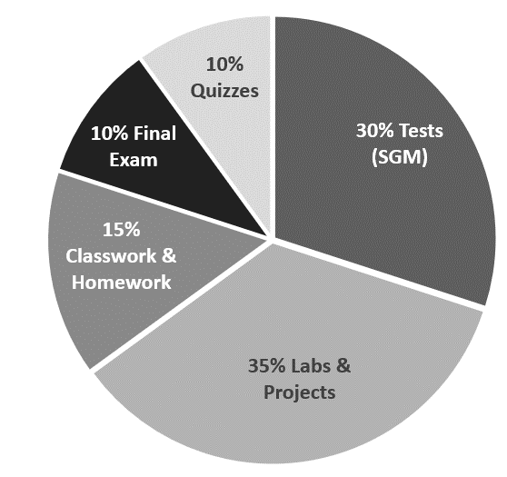
Grades

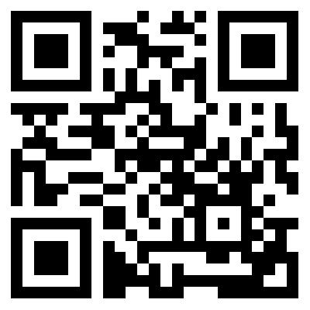
Scan for class website!
Contains additional information

Late Work:
- Work turned in up to two weeks after the assignment due date will only receive 50% credit
- Work turned in 3 to 4 weeks after the assignment due date will only receive 30% credit
- Late work will not be graded after 4 weeks past the due date
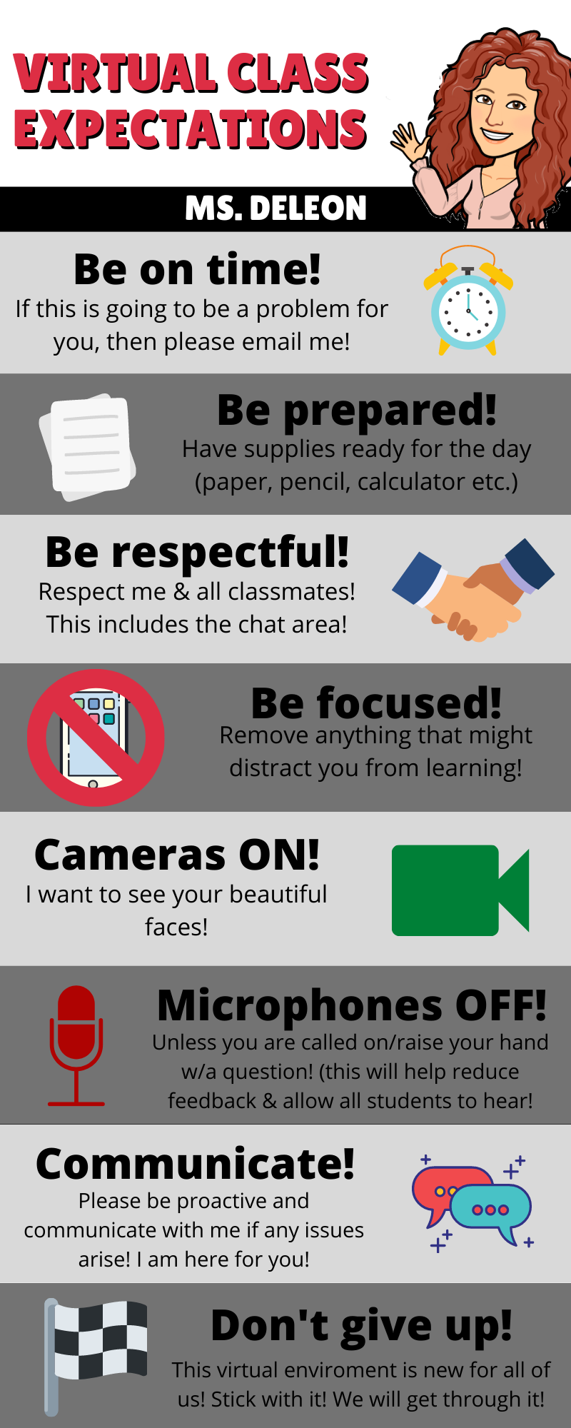

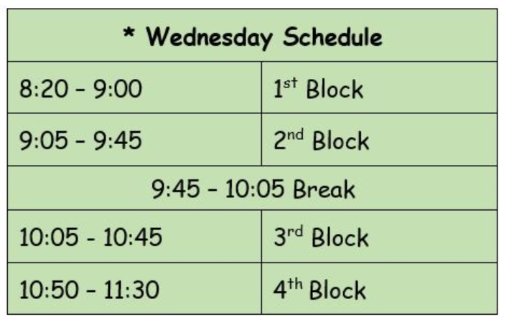
Need Extra Help?
Log on during Wednesday’s review session.

