Biome & Animal Adaptation Project
50 Project Points
You have been randomly assigned a biome to research with your group. (Students who are absent on both in-class work days must perform all of the research on their own). You may not change groups or research a different biome.
Purpose: Inform others about your biome and encourage them to choose your biome as their #1 travel destination.
Product: Your group will produce an informative travel brochure (this can be done using Microsoft Publisher), poster or octahedron.
Grading: In addition to the rubric, you will be graded by your peers’ votes (students will view each brochure and then vote for their top 3 travel destinations – not counting their own assigned biome).
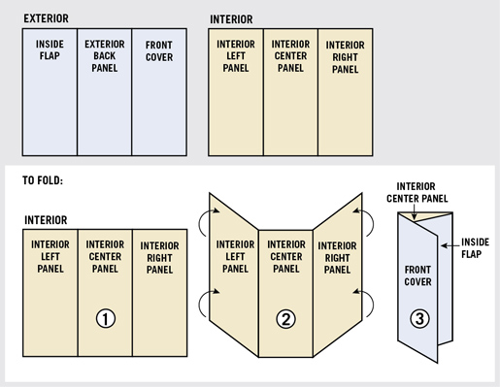
The Details:

Guidelines for your brochure:
Note: If creating a poster or octahedron-use the following as guidelines for subheadings.
- Title Page (Right column, the one that folds to the front)

  - Name of your biome
  - Picture of your biome
  - Class block
  - Names of all participating group members

- Page#1 – Left Column (inside)
  - Map of the world with your biome highlighted
  - Flora: 5 or more plants in this biome. For 2 of the plants, give pictures and adaptations they have that suit them well to this biome and climate.
- Page #2 – Center column (inside)
  - Climate of your biome (average daily temperature, a chart or graph of seasonal temperatures throughout the year, what seasons your biome has, chart or graph of seasonal precipitation of your biome)
  - Guide for how travelers: Best time of year to visit and how they should dress when visiting your biome during this time

- Page #3 – Right column (inside)
  - Fauna: 5 or more animals in this biome. For 2 of the animals, give pictures and adaptations they have that suit them well to this biome and climate.
  - Food Web for an organism at the highest trophic level in this biome OR Food pyramid showing examples of organisms that are producers, primary consumers, secondary consumers, and tertiary consumers (if applicable) Must be made by you – not downloaded/copy-pasted.
- Page #4 – Left column (outside, the one that folds underneath the title page)
  - 5 or more threats to your biome, with some details about each threat (be sure to include natural as well as human-induced threats). 1 picture related to one of the threats.
- Page #5 – Center column (back of brochure)
  - Traveler’s Guide
    - Public parks or lands to visit in your biome
    - Top 5 reasons to visit your biome
    - Interesting pictures related to any of the parks or top 5 reasons
  - Citations
    - Note the website titles or book titles of any resources that you used. (Not official APA or MLA citations – just something that the traveler could access to find out more about this biome).
Projects should contain correct grammar and spelling. Graphs of temperature and rainfall can be inserted from a reputable weather source, provided you include that site in your citations list on the back. You may use both your textbook and any credible scientific Internet sources (not Wikipedia) to find your information.

Keep the following in mind when creating your product
- Size & type of font
- Subheadings for sections of poster
- Neatness, creativity & color
- Legibility-other students will be using this as their primary resource for notes!

Suggested sites:
Cobb Virtual Library Science in Context
Thewildclassroom.com
http://www.ucmp.berkeley.edu/glossary/gloss5/biome/
https://earthobservatory.nasa.gov/Experiments/Biome/
http://www.blueplanetbiomes.org/world_biomes.htm

Elaboration on Fauna (page 3 of brochure):

Consider and include the following when referring to animal adaptations: Think about how the following help the animal survive:
- Size of animals
- What they eat
- How does it catch its food or get water
- How does it stay warm/cool
- Where does it shelter
- How does it protect/defend itself from attackers

